Program Description
Harold Alfond College Challenge (HACC) 2017 Savings Brief
At its inception, the Harold Alfond College Challenge (HACC) offered a $500 grant to every Maine resident infant for whom a NextGen 529 college savings plan account was opened by the baby’s first birthday. Enrollment involved a two-step process, including an addendum to the NextGen application, required in order to accept the Alfond Grant. While the money for the $500 HACC grants comes entirely from the Harold Alfond Foundation and is granted initially to the Alfond Scholarship Foundation before being invested for eligible Maine babies, the state is an important partner, providing the delivery system of the 529 college savings plan, matching and auto-funding incentive grants, and data-sharing. Accountholders who make contributions to NextGen accounts may also benefit from tax advantages associated with 529s.
Table 1. Participants’ Household Income at Account Opening
Income Range | Frequency | % | Cumulative %
Less than $25,000 | 1333 | 10.2 | 10.2
$25,000-$49,999 | 2754 | 21.0 | 31.2
$50,000-$74,999 | 3396 | 25.9 | 57.1
$75,000-$149,999 | 4590 | 35.0 | 92.1
$150,000 + | 1035 | 7.9 | 100.0

Account Opening by Household Income
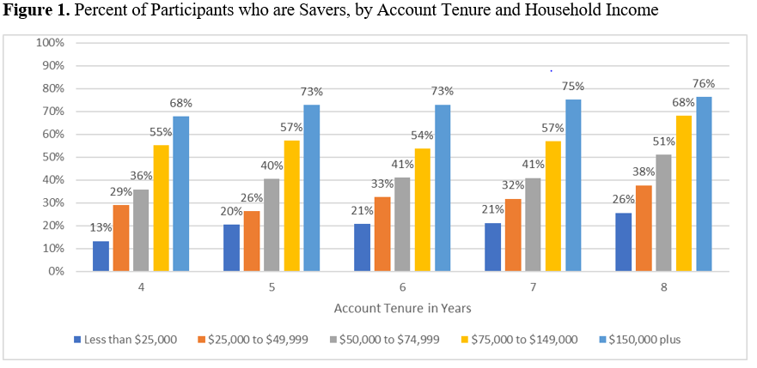
Our finding that 57% of those who opened a NextGen College Investing Plan account in order to receive a HACC grant had household incomes less than $75,000 per year (Table 1), suggests greater representation in the HACC by relatively modest-income households than what national reports of 529 college savings plan ownership have found. Some surveys find that 529 account ownership is more than twice as likely (49%) among high-income as middle- (20%) or low-income (17%) families.

Percentage Savers by Household Income
While it is encouraging that low-income households are saving in their HACC account, Figure 1 shows they are far less likely to save than their higher-income counterparts, regardless of account tenure. For example 26% of the lowest-income HACC participants whose accounts were opened 8 years ago (in 2009) have made at least one contribution, compared to 76% among households with incomes of $150,000 or more. As would be expected, across income groups, the proportion of HACC recipients who are ‘savers’ increases slightly with length of account ownership, but the patterns between groups remains the same.

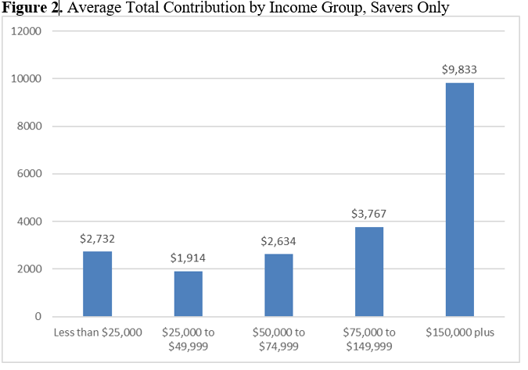
Household Contributions by Household Income
Figure 2 shows average total contributions by household income. As illustrated, there is relatively little difference between average total contributions of households earning less than $75,000 per year; the widest gaps do not open until households earn at least $150,000 per year. This suggests that Children’s Savings Accounts such as the HACC may play a role in reducing wealth inequality among households whose outcomes may otherwise be more divergent.

Average Total Value of Account by Family Income
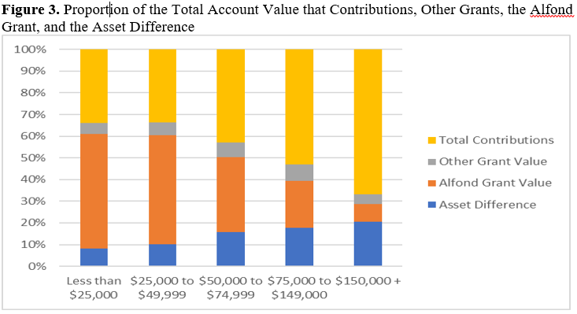
We found little difference in average asset value among the bottom three income groups. Households earning less than $25,000 have an average asset value of $1,614, households earning $25,000 to $49,999 have $1,731, households earning $50,00 to $74,999 have $2,541, and households earning $75,000 to $149,999 have $4,069, and households earning $150,000 or more have $10,815.

This lack of variation among lower-income groups is further described in Figure 3, which illustrates the differential asset accumulation dynamics of HACC participants, by household income. Particularly notable is the greater return on investment realized by the highest-earning households. Denoted in blue as the ‘Asset Difference’, this amount is the difference between the sum of the component parts of the HACC account (Total Contributions + Other Grant + Alfond Grant) and the total value of the account. These returns are most evident in the case of the highest-income group—those earning more than $150,000 annually—and smaller for lower-income families. This suggest that the wealth of higher-income families—who are able to save more and thus earn more from their accounts—is more generously augmented within this college-saving structure than that of lower-income families. Some of the components of the asset value—such as the NextStep matching grants—further amplify these effects, since they require contributions in order to be valuable. Also visible in this figure is the outsized importance of the $500 HACC grant, to the total asset holdings of lower-income households.

The report was written by the Center on Assets, Education, and Inclusion (AEDI) at the University of Michigan School of Social Work. Support for this research was provided by the Charles Stewart Mott Foundation. The full report can be found at http://aedi.ssw.umich.edu/publications/1877-harold-alfond-college-challenge-hacc-2017-savings-report-for-households-who-opted-in-to-the-program-from-2008-to-2013.
Sallie Mae. (2015). How America Saves for College. Washington, DC: Author. Retrieved from: https://www.salliemae.com/plan-for-college/how-america-saves-for-college/.

